**Changing Occupational Profiles – A Methodology to Illustrate Future Demand on the EO/GI Sector**

As a contribution to the set of methods proposed for the development of the sector skill strategy, PLUS proposes an analysis of current workflows and expected changes of these workflows. The suggested analysis consists of the following steps:

1. Workshop for capturing duties and tasks of a specific occupational profile in the wide EO/GI domain (‘DACUM Workshop’).

2. Indication of required skill levels (transversal skills, technical skills, competencies) for the tasks identified in the workshop.

3. Analysis of (technological) trends related to a specific occupation and illustration of effects of trends on tasks of an occupational profile.

**Deadline for steps 1 and 2: February 8, 2019**

**Deadline for step 3: February 19, 2019**

Estimation of time needed:

* Preparation of workshop and exercise: 3-4 hours
* Implementation (workshop participation per person): 4-6 hours
* Analysis of skill levels and trends: 5-8 hours

The selection of partners for the exercise is based on the resources foreseen for task 1.5 (sector skill strategy development). You can count the hours used for this task.

We propose some specific occupational profiles to be analysed to the partners participating in this exercise. Partners are free to choose another occupational profile of interest in your organisation. The idea of asking a set of EO4GEO partners to participate in this analysis is to increase the breadths of analysed profiles. The analysis shall support the development of a sector skill strategy; therefore, we need to find out more about different profiles required in organisations.

PLUS has completed all steps of the proposed exercise for the profile of a “remote sensing specialist”. In case of any questions along the way, please do not hesitate to contact Nicole Ferber ([nicole.ferber@sbg.ac.at](mailto:nicole.ferber@sbg.ac.at)) and/or Barbara Hofer ([barbara.hofer@sbg.ac.at](mailto:barbara.hofer@sbg.ac.at)).

**Provided materials alongside this overview:**

* Slides for the preparation of a DACUM workshop: <https://eo4geo.slack.com/files/U9B2RP5T2/FFBLY7JCF/dacum_workshop.pptx>
* PPT Templates for the mapping of skills and trends to the chart of an occupational profile: <https://eo4geo.slack.com/files/U94086SGH/FFC0H5A78/profile_templates.pptx>
* Overview on participating partners: <https://eo4geo.slack.com/files/U94086SGH/FFF9Q4VFS/dacum_workshop_involvedpartners_nf.xlsx>

**Ad 1) Instructions for the DACUM Workshop on an Occupational Profile**

The analysis of a professional profile is conducted through an interactive workshop following the DACUM approach: DACUM (Design A CurriculUM) has been designed in the 1960s in Canada for achieving a job-oriented education. The aim of DACUM is to analyse a job and to derive duties and tasks as well as required technical skills and personal traits in recurring discussion rounds. The discussions involve experts in the field who reach consensus on the job profile during the discussion process. The selection of experts for the DACUM discussions is essential for the quality of the outcome.

There are a series of examples of DACUM profiles of the GI and EO sectors (<http://www.geotechcenter.org/gtcm-dacum.html>) as well as a meta-analysis of developed profiles in the GI sector ([Johnson](http://www.geotechcenter.org/uploads/2/4/8/8/24886299/gistech_andsuppurisajournalvol22issue2.pdf) 2010).

I**n general consider the following before conducting the DACUM workshop:**

1. Watch the video to familiarize with the DACUM process<https://www.youtube.com/watch?v=gklQ7lPxvNk>
2. Find a facilitator (preferable not a person in a management position) qualified to conduct a workshop
3. Plan 4-6 hours, depending on the size and composition of the group, for the workshop
4. Invite 3 to 8 expert workers from your organisation working in the occupation to be analysed (the majority must be actual workers rather than supervisors and managers)
5. Organize a room suitable for the workshop
6. Organize supplies (whiteboard or pinboard, cards of various colours and sizes, pen etc.)

## **Who is qualified as facilitator**

The facilitator must establish and maintain the group's pace, balance the group's participation, clarify vague statements by probing for more details, and insist on selection of the most appropriate action verbs, task statement modifiers, and objects (nouns) in composing duty and task statements. The facilitator must motivate and lead the group and control the process, yet never impose content judgments or decisions on the participants ([Norton](https://files.eric.ed.gov/fulltext/ED401483.pdf) 1997 p. 21).

According to the "DACUM on DACUM" committee, the facilitator should exhibit the following worker behaviors (Norton p. 20):

· A professional image and outlook

· A sensitivity for others

· The ability to establish and maintain enthusiasm

· A sense of humor

· The ability to show empathy

· The ability to display and maintain a positive image

· Patience

· The ability to make decisions

# **How to conduct a DACUM workshop?** ([Norton](https://files.eric.ed.gov/fulltext/ED401483.pdf) 1997 p. 131)

* Start the workshop in providing a brief definition of the occupation to be analyzed (we provide proposals which occupational profile might be of relevance in your organisation)
* Explain the DACUM philosophy (use selected slides from the [provided ppt)](https://eo4geo.slack.com/files/U9B2RP5T2/FFBLY7JCF/dacum_workshop.pptx)
  + Explain briefly its major uses and applications
  + Describe briefly the workshop process
  + Describe briefly the benefits and advantages
  + Emphasize its effectiveness, the short-time required, and its low cost
  + (If needed display some sample DACUM charts like: [http://www.geotechcenter.org/uploads/2/4/8/8/24886299/remotesensingdacum_denver_2011.pdf](https://atecentral.net/g29159/f4) )
* Review the job/occupation:
  + Conduct initial brainstorming
  + Develop occupational chart
    - Identify duties (general areas of responsibility)
    - Identify specific tasks performed
* If possible list the 3 to 5 main:
  + General knowledge and skill requirements of the job
  + Worker behaviour (desirable attitudes and traits)
  + Tools, equipment, supplies and materials
  + Future trends/concerns
* Review/refine task and duty statements

**Major DACUM Workshop Outcomes**

1. A graphical representation (DACUM chart, see below Figure 1) with precisely states job tasks/duties (please insert in provided template)
2. List general knowledge and skills requirements
3. List of tools, equipment, supplies and materials required for the job
4. List of future trends
5. Take a photo during the workshop

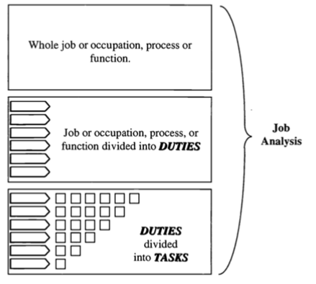

Figure 1 DACUM chart ([Norton](https://files.eric.ed.gov/fulltext/ED401483.pdf) 1997)

**Ad 2) Adding Skill Levels to the Identified Tasks**

As the intention of this exercise is to support the development of the EO4GEO sector skill strategy, information on knowledge, skills and competencies required for tasks are important. According to the definition of Cedefop (2014):

* “Knowledge is defined as the outcome of the assimilation of information through learning. It represents the body of facts, principles, theories and practices related to a field of work or study.
* Skills indicate the ability to apply knowledge and use know-how to complete tasks and solve problems.
* Competence means the proven ability to use knowledge, skills and personal, social and/or methodological abilities, in work or study situations and in professional and personal development.”

In the context of tasks of occupational profiles skills, knowledge is an implicit requirement for accomplishing tasks; knowledge alone will rarely be required. Therefore, we ask you to mark the following types of skills required for the specific tasks:

* transversal skill/soft skills: transversal skills relate to communication, time management, language skills etc. So, all skills that are not specific to a domain.
* technical skill: task requiring knowledge of a technique or programme; in the context of this analysis it is assumed that standardized procedures or guidelines on how to perform tasks exist or algorithms are in place to support the specialists. (For example, the task of geometric correction, which is classified as task requiring technical skill, might require competencies if there are no routines available for the correction.)
* competency: competencies are a the combined use of knowledge and skills for tasks together with personal and social abilities and also include experience.

Figure 2 contains an example of the mapping of types of skills to tasks. The provided [powerpoint template](https://eo4geo.slack.com/files/U94086SGH/FFC0H5A78/profile_templates.pptx) includes a reusable example for this mapping.

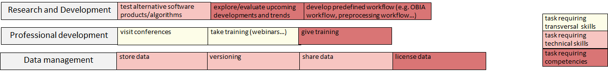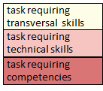

Figure 2: Tasks of an occupational profile marked with the type of required skill or competency.

**Ad 3) Optional: Identification of Trends Affecting an Occupational Profile**

Once the occupational profile has been established, it is interesting to anticipate if and how tasks of the profile are subject to change. Change is brought along due to technological advances in our domain like the strong use of cloud platforms or the provision of analysis ready data.

The analysis of trends requires an overview on the domain in which the occupational profile is situated and some knowledge on ongoing developments in the field. For the example of the remote sensing specialist, PLUS identified the following main trends:

* the increased use of platforms for data storage (PaaS),
* the availability of analysis ready data,
* the increased use of platforms for image pre-processing and analysis (INFOaaS),
* the automation of image analysis and the production of scene classification maps (SCM).

Once trends have been identified, they can be mapped to the occupational profile to indicate which tasks are affected by which trends. The time frame of the forecast in the exemplary analysis is 5-10 years, which means that we expect ARD, PaaS and INFOaaS to have passed their current state of development and are fully usable. An example for such a mapping is shown in Figure 3 (reusable version of the diagram available in the provided [powerpoint document](https://eo4geo.slack.com/files/U94086SGH/FFC0H5A78/profile_templates.pptx)).

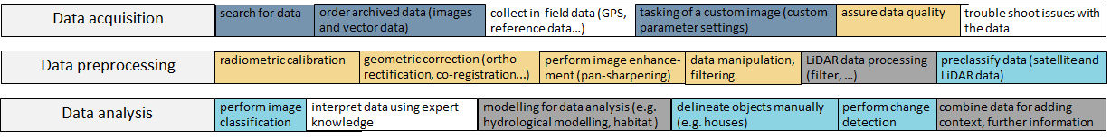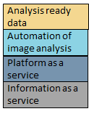

Figure 3: Mapping of trends on tasks of an occupational profile.

The trends might have different impacts on the tasks: e.g., analysis ready data might make some preprocessing tasks superfluous; the use of cloud platforms on the other hand might only affect the work environment of tasks. Based on the specification of the nature of changes brought about by trends, one can indicate which tasks are likely to be crossed-out from current workflows.

**References**

Cedefop (2014) Terminology of European education and training policy: a selection of 130 terms, 2nd edition. in Publications Office, (ed.), Luxembourg.

Johnson, J. (2010) What GIS Technicians Do: A Synthesis of DACUM Job Analyses.

Journal of the Urban & Regional Information Systems Association, 22(2), pp. 31-40.

Norton, R. E. (1997). DACUM Handbook (2 ed.): Center on Education and Training for Employment, College of Education, The Ohio State University, Columbus, Ohio.